**Selecting the Optimal Restaurant Location in Philadelphia**

Holden Miller-Schaeffer

03/02/2020

1. **Introduction**

I have been approached by a local businessman in search of a data science professional. He wants to open a restaurant in Philadelphia, however, he wants to avoid as much competition as possible. He is wondering where the ideal neighborhood is to open a restaurant in Philadelphia. Which type of restaurant depends on location and frequency of other restaurants in the area.

1. **Data**

The data used to solve this problem was gathered from two separate locations. I used Philadelphia neighborhood Zip Codes geojson from [this site](https://www.opendataphilly.org/dataset/zip-codes) to gather a list of all zip codes in Philadelphia and the latitude and longitude coordinates. The geojson includes a list of all Philadelphia zip codes, and all latitude and longitude coordinates within that area. I averaged the latitudes and longitudes of each zip code in order to find the center point of the neighborhood.

After gathering and cleaning the geojson file, I found a list of Philadelphia zip codes and neighborhood names [here](https://www.snaderrealestate.com/philadelphia-zip-codes-and-neighborhoods/). I used this to create my own csv file with the name of each neighborhood and its corresponding zip code in order to create a combined table of zip codes and neighborhood names.

My final step in gathering data was using Foursquare’s location data API in order to find the type and frequency of venues in each neighborhood.

1. **Methodology**

Using Folium, I created a map to visually segment each Philadelphia neighborhood.

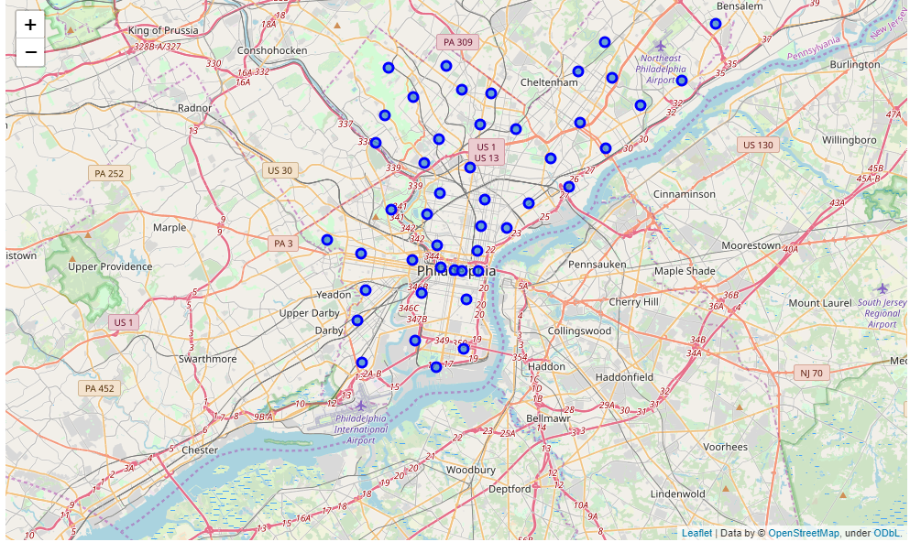

Using this visual representation of Philadelphia, it becomes much easier to identify each neighborhood and present the information to the appropriate stakeholders. After creating neighborhood segments, I used FourSquare location data to get the names of venues in each neighborhood. I filtered down to include only restaurant venues.

By using Kmeans clustering, I created a map of neighborhood clusters in Philadelphia, based on the frequency of restaurants in each area.

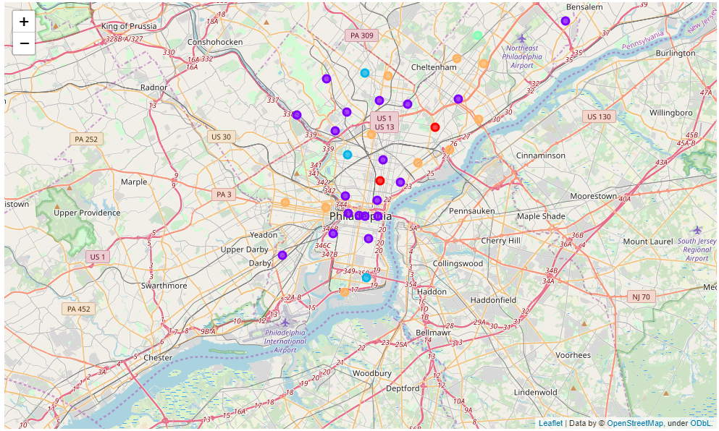

1. **Results**

I was able to determine that the best restaurant location would be in any of the blue, red, or yellow clusters. The purple clusters represent a high frequency of restaurants and would result in more competition. Furthermore, the yellow clusters are more ideal than red or blue, as they represent areas in popular areas where consumers go to eat, but where they are not overwhelmed by other selections. The most optimal place to open a restaurant based on this data is University City, as it is closest to downtown and has a large concentration of students from UPenn.

1. **Discussion**

As mentioned above, the ideal restaurant location in Philadelphia is University City, based off of proximity to Center City and frequency of other restaurants in the area. Secondary locations to consider are any of the yellow dots, which are popular destinations for consumers, but not overcrowded eating locations such as Center City. The competition is much lower in these outside neighborhoods, but there is still a large volume of people who will come to eat.

1. **Conclusion**

In this study, I analyzed neighborhood latitude and longitude coordinates in order to isolate all the types and frequencies of restaurants in the city of Philadelphia. I was able to conclude that the optimal location to open a restaurant in Philadelphia is in University City, where there is less competition, but it is close enough to downtown and other restaurants that it will still attract a consumer base. In the future, I hope to delve deeper into this analysis and determine if there is a better place to open a specific type of restaurant.